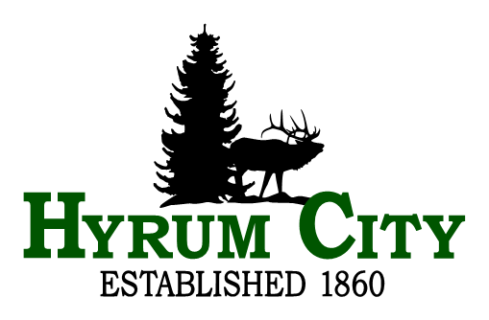

NOTICE OF PUBLIC HEARING

The Hyrum City Council will hold a public hearing Thursday, June 5th, 2025 at 6:30 p.m. in the City Council Chambers, 60 West Main, Hyrum, to consider the following:

- Adjustments to the 2024-25 general and enterprise operating budgets.

- The adoption of fiscal 2025-26 operating budgets for the General Fund, the Capital Projects Fund, the Culinary Water Fund, the Sewer Treatment Fund, the Electric Fund, the Irrigation Water Fund, the Storm Water Fund, and Sewer Collection Fund.

- Setting salaries of elected and appointed officials; Department/Division Supervisors/Directors and their assistants; and other municipal employees for 2025-26 and amending Section 2.12.010 of the Hyrum City Municipal Code.

Copies of the proposed amendments to the 2024-25 budget and the proposed 2025-26 operating budgets tentatively adopted by the City Council are available for public inspection at the City office, 60 West Main, weekdays between the hours of 8:00 a.m. and 4:30 p.m. and on the City’s website at www.hyrumcity.gov.

_____________________________________
Stephanie Fricke
Hyrum City Recorder

Published date: May 20,2025

Posted: State Public Notice Website;
Hyrum City Website; and
Ridleys Grocery Store, Hyrum City Office, Senior Center, and Library, Hyrum Chevron, Cache Valley Bank, Manning Short Stop on May 20, 2025

