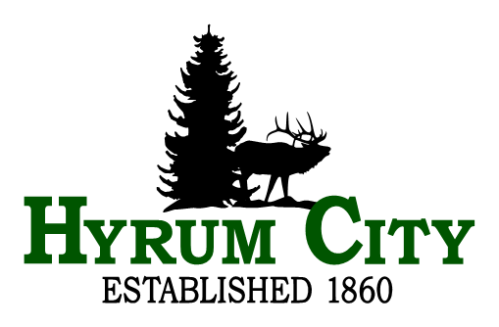

election notice

The following individuals have filed for Mayor in Hyrum City (1 seat available)- Stephanie Miller, Steve J. Miller, and Shara Toone; and for City Council in Hyrum City (2 seats available) - Joshua Kyle Cannon, Jared Clawson, NaLyn Nelson, Paul James, Rebecca Foulger, and Kevin J. Petersen.

There being more than twice the number of candidates filed for both the Mayor seat and City Council seats than are available, a Primary Election will be held on August 12, 2025. The names of the two Mayor candidates, and four City Council candidates that receive the majority of the votes in the Primary Election will be placed on the November ballot. The Municipal General Election will be held on November 4, 2025.

This notice is published pursuant to 20A-9-203(8) of the Utah State Code.

___________________________________
Stephanie Fricke
City Recorder

Dated: June 9, 2025

Posted June 9, 2025: Hyrum City Website
Utah Public Notice Website
Hyrum City Offices
Hyrum City Library
Hyrum Senior Center
Ridley’s Grocery Store
Short Stop
Cache Valley Bank
Emailed June 9, 2025: State of Utah Lt. Governor’s Office
Cache County Clerk

