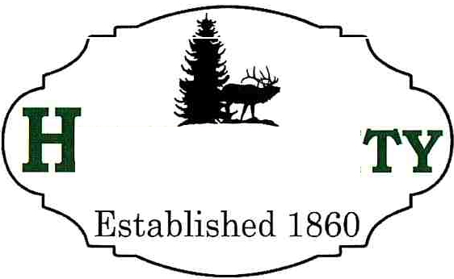
Mayor, Steve J. Miller

YRUM CI
Council Members
Steve Adams Rebecca Foulger
NaLyn Nelson Michael Nelson Craig Rasmussen
Recorder
Stephanie B. Fricke
Treasurer
Todd Perkins

NOTICE OF PUBLIC HEARING
Notice is hereby given that the Hyrum City Planning Commission of Hyrum City, Utah will hold a public hearing Thursday, March 12, 2026 at 6:30 p.m. in the Hyrum City Council Chambers, 60 West Main, Hyrum. The purpose of this hearing is to receive public comment regarding a request from Sergio Bustillos to rezone property from Residential Agriculture Zone RA to Light Manufacturing Zone M-1 located at approximately 230 North 100 East.

Copies of the proposed amendments are available at the Hyrum City Office, 60 West Main, Hyrum, weekdays between the hours of 8:00 a.m. and 4:30 p.m., and on the City's website at www.hyrumcity.gov.

Shara Toone Deputy Recorder

Published: State Public Notice Website and Hyrum City Website on February 27, 2026.
Posted: Ridleys Grocery Store, Hyrum City Office, Senior Center, and Library, Hyrum Medical Clinic, Cache Valley Bank, Manning Short Stop on February 27, 2026.

